Green Team
Database Use and Development
Milestone 3
Module 10

Report 1 – Equipment Older Than Five Years:

Business Question
Are any pieces of equipment older than five years and potentially due for replacement?

Description of the Report
This report queries the EQUIPMENT table and uses acquired_date to calculate the age of each item in years. It uses TIMESTAMPDIFF to compare the acquisition date to today’s date and returns only items that are more than five years old. For each piece of equipment, the report shows the ID, name, type, condition, acquisition date, and age in years.

Why This Report Is Useful
Older gear can be unsafe, harder to maintain, or give customers a bad experience. By listing equipment older than five years, this report gives the inventory manager a clear list of items that should be inspected and possibly replaced. It supports safer trips and helps Outland Adventures plan future equipment purchases and budgets.
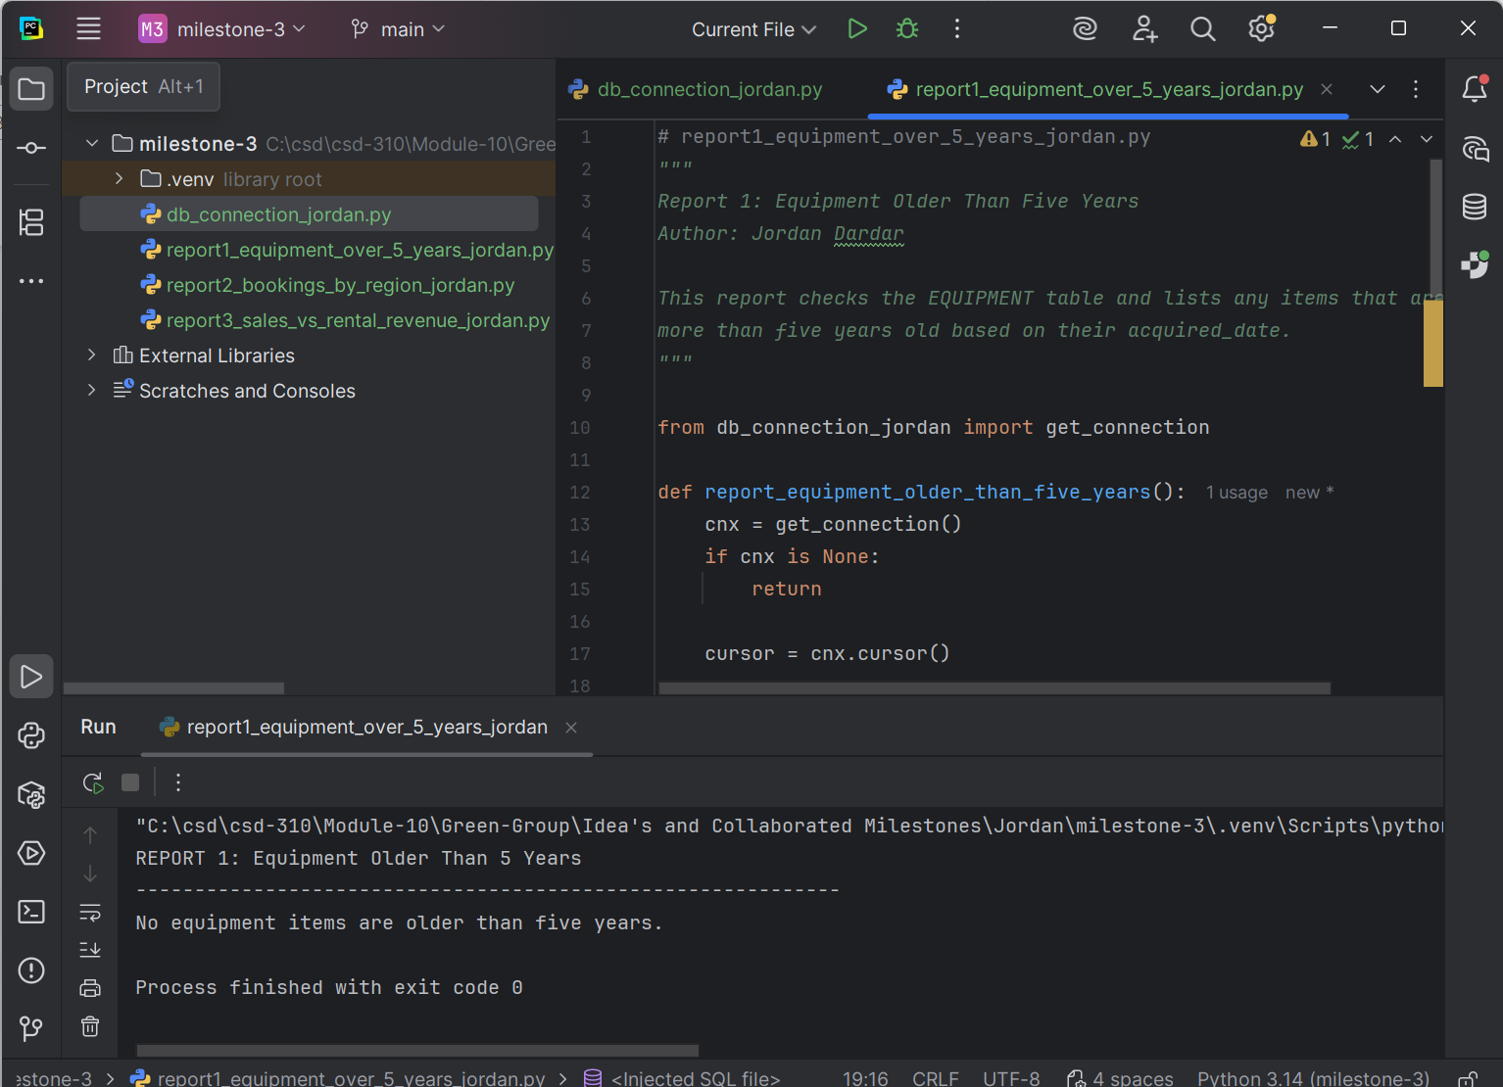
Report 2 – Booking Trends by Region:

Business Question
Are any regions, such as Africa, Asia, or Southern Europe, losing popularity based on recent bookings?

Description of the Report
This report joins the BOOKING, TRIP, and REGION tables. For each booking, it finds the related trip and the region that trip belongs to. The query then groups the data by region_name and counts the total number of bookings for each region. The final output shows each region and its total bookings, ordered from highest to lowest.

Why This Report Is Useful
By comparing bookings across regions, the owners can quickly see which areas are in high demand and which ones may be slowing down. If a region has low or declining bookings, the company might adjust marketing, offer promotions, or even cancel underperforming trips. Strong regions could be expanded with additional trips or new itineraries.
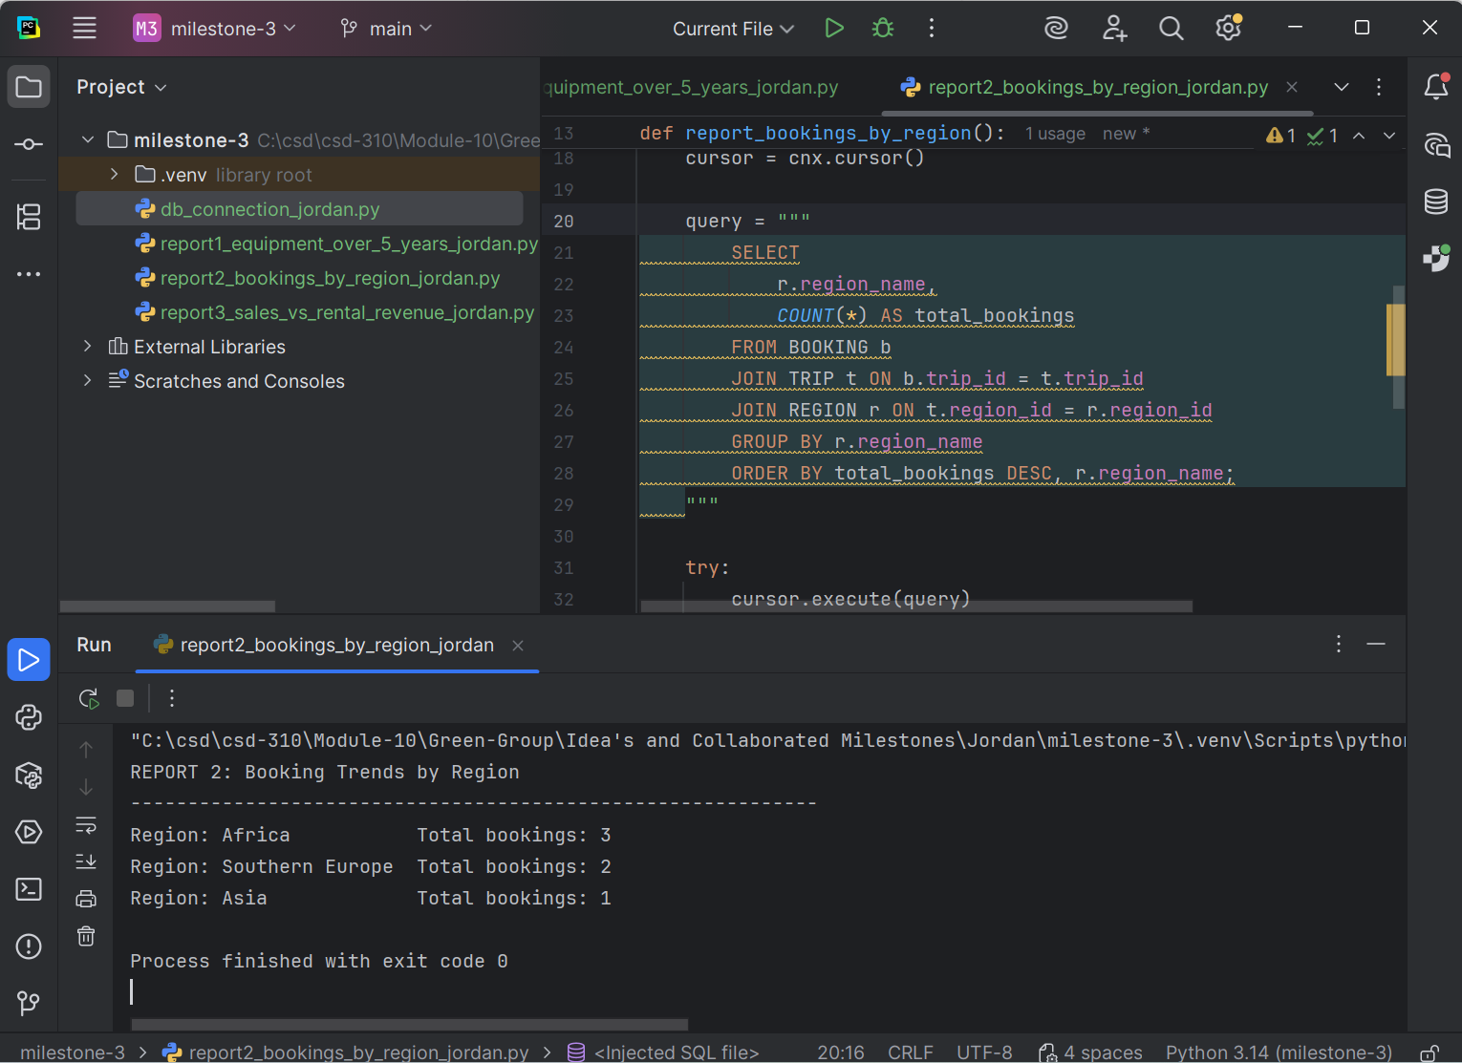

Report 3 – Sales vs Rental Revenue:

Business Question
Does Outland Adventures earn more revenue from selling equipment or from renting it?

Description of the Report
This report joins the EQUIPMENT_ORDER and ORDER_LINE tables. For each order, it multiplies quantity by price_each to calculate the line total, and then sums these amounts for each order_type (SALE or RENTAL). The output displays the order type and the total revenue associated with that type.

Why This Report Is Useful
The owners need to know whether it is more profitable to focus on selling equipment or renting it. If rental revenue is higher, they might want to expand the rental inventory and keep more items available for trips. If sales revenue is higher, they could shift strategy toward selling more gear and reducing the complexity of rentals. This report gives them concrete numbers to compare the two sides of the business.
